Mohammed Zain-Ul-Abideen

Introduction
Many students, especially those aged between 12 and 18, struggle with managing academic tasks and deadlines due to increasingly demanding workloads and complex schedules. In many cases, they attempt to remember all upcoming responsibilities mentally, which leads to unnecessary stress, missed deadlines, and gaps in learning. These missed opportunities not only impact academic progress but also create long-term setbacks, as students are unable to build on incomplete knowledge.
This is a common real-world problem that is well-suited to a computational solution. Existing platforms, such as Google Classroom, offer task tracking but lack effective reminder systems, relying primarily on email notifications. Given that many students in this age group do not check their emails regularly, these reminders often go unnoticed, reducing their usefulness.
To address this, I will design a to-do list system specifically tailored to students, incorporating intelligent features to increase productivity and academic performance. Users will be able to add tasks with specific deadlines and receive push notifications as those deadlines approach. The system will also recommend personalised revision strategies and study sessions based on user input, academic weaknesses, and task urgency.
To prioritise tasks efficiently, I will develop algorithms that evaluate priority levels and areas of weakness, using data structures such as stacks and queues. These will help order tasks dynamically, guiding users to focus on what matters most. The GUI will be intuitive and accessible, allowing users to view and manage their tasks with ease. By providing timely reminders and smart scheduling recommendations, the application aims to reduce mental load, promote better time management, and ultimately improve student performance.

Stakeholders
The target demographic my system will be created for is students aged 12-18, who would be interested in the organising and simplification of task scheduling and its features of recommended task performing based on priority and weakness. The testers of my system will most likely be the students in my Computer Science class as black box testers.

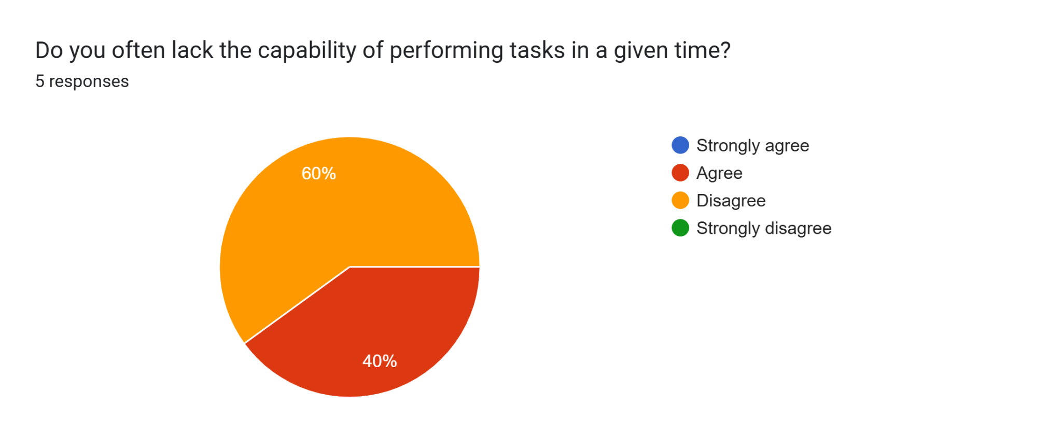
The key stakeholders for the problem of students generally not being able to complete assignments within deadlines are secondary school students between the ages of 12 and 18, who need help in managing numerous assignments and deadlines. Teachers are also stakeholders since they want to receive improved timely submissions and fewer late penalties, while parents worry about promoting good study habits among their children and reducing homework stress. School IT departments are interested indirectly if it is used on school hardware. A survey revealed 60% of students agree they do have an issue, while 40% do not, which suggests an obvious need for a task management instrument with reminders and prioritisation features, but with facilities that can be customised so conscientious planners are not overwhelmed. The system must strike a balance between formal support and flexibility to accommodate the needs of all users as well as serve teachers' and parents' interests in enhancing improved academic practices.

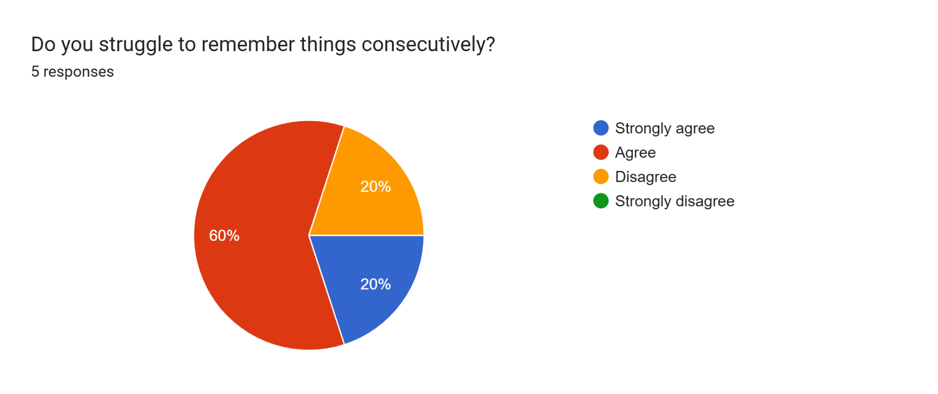
The primary stakeholders of the problem of students struggling to remember things in sequence are secondary school pupils aged 12 to 18 years, and they are not able to recall different tasks and deadlines in the correct order. Teachers are secondary stakeholders since they want students to carry out instructions in sequence and complete work in sequence to prevent classroom disorder and late marking. Parents also want to enhance the organisational skills of their children and decrease stress at home. Of the students surveyed, 60% agreed and 20% strongly agreed that it is difficult for them to do so, with just 20% disagreeing, therefore indicating a high incidence of a need for a system for sequential task tracking and reminder. The system needs to allow learners to break work into reasonable steps and offer memory reminders, but still be flexible enough for individuals who already feel they can manage their own timetable, therefore catering for the needs of all user groups.

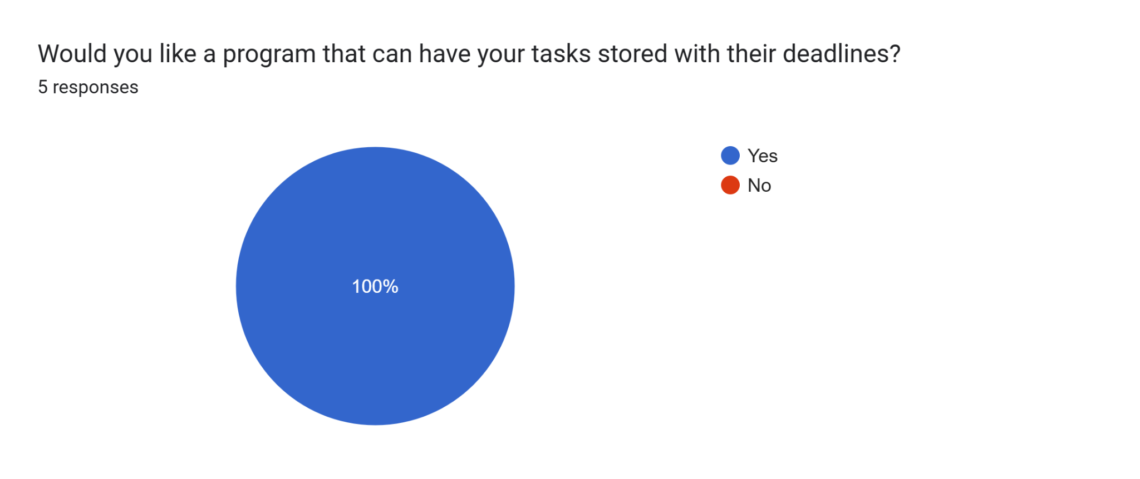
The immediate stakeholders for my deadline-task-storing program are secondary school students aged 12–18 who need to be helped in organising their workload so they do not miss submissions and last minute stresses. Teachers are indirect stakeholders since better organised students translate to more manageable marking schedules, while parents have stakes in their children being independent in handling school stresses. The 100% response rate within the survey outcome illustrates universal need for this feature, which means that it is a necessity for any proposed solution to include clear, accessible task storage with deadlines to meet student demand and facilitate improved academic planning for all parties.

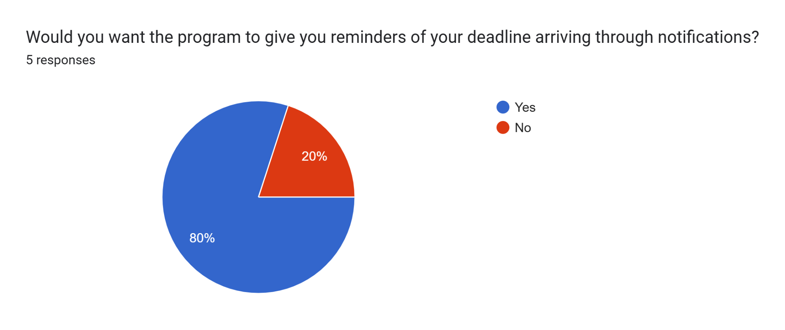
The most significant stakeholders for the notification feature are students who constantly forget deadlines if not reminded, teachers who deal with late assignments and parents who want to reduce conflicts over missed assignments. With 80% saying yes and 20% no, the overwhelming majority expresses a strong preference for reminders, with any system that suggests customisable notifications helping to aid students in staying on top of things while also respecting those who may choose to turn them off.

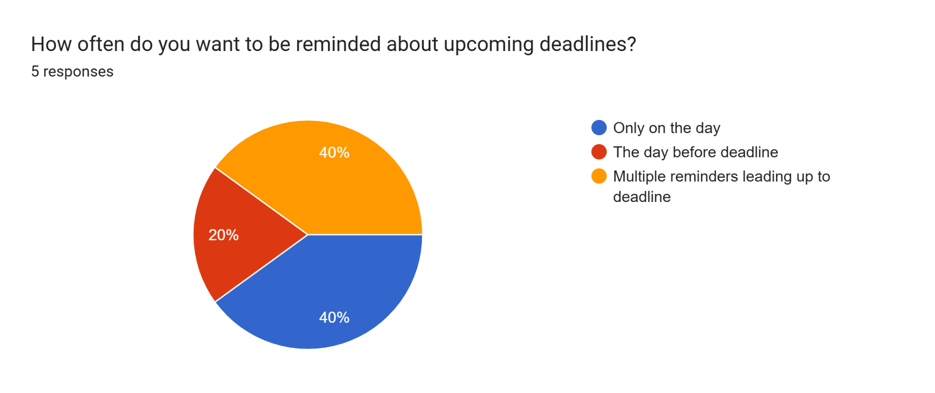
Students are the direct stakeholders in this situation, needing customised reminders to fit individual study routines and attention spans. Teachers are indirectly benefited if students submit work on time as a result of punctual reminders. The responses indicate a split preference, 40% for same-day reminders only, 40% for several reminders, and 20% for a day before reminder for incorporating a customisable reminder timetable in the solution to enable students to choose the frequency that would best support their time management.

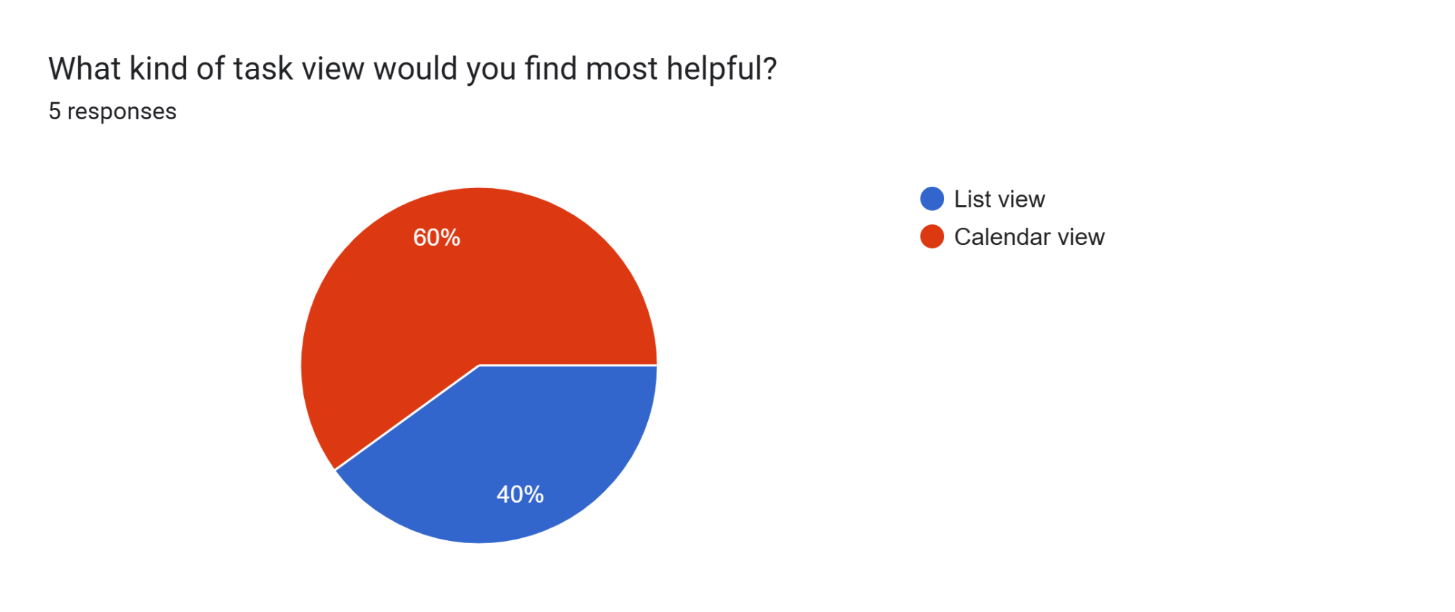
The direct stakeholders are students managing complex timetables and multiple subjects, while teachers benefit when students can clearly see upcoming deadlines. Survey results show 60% prefer a calendar view for visual planning and 40% prefer a list view for simplicity. This suggests the program should support both formats, allowing students to switch between views to best match their organisational style, making it more inclusive and effective.

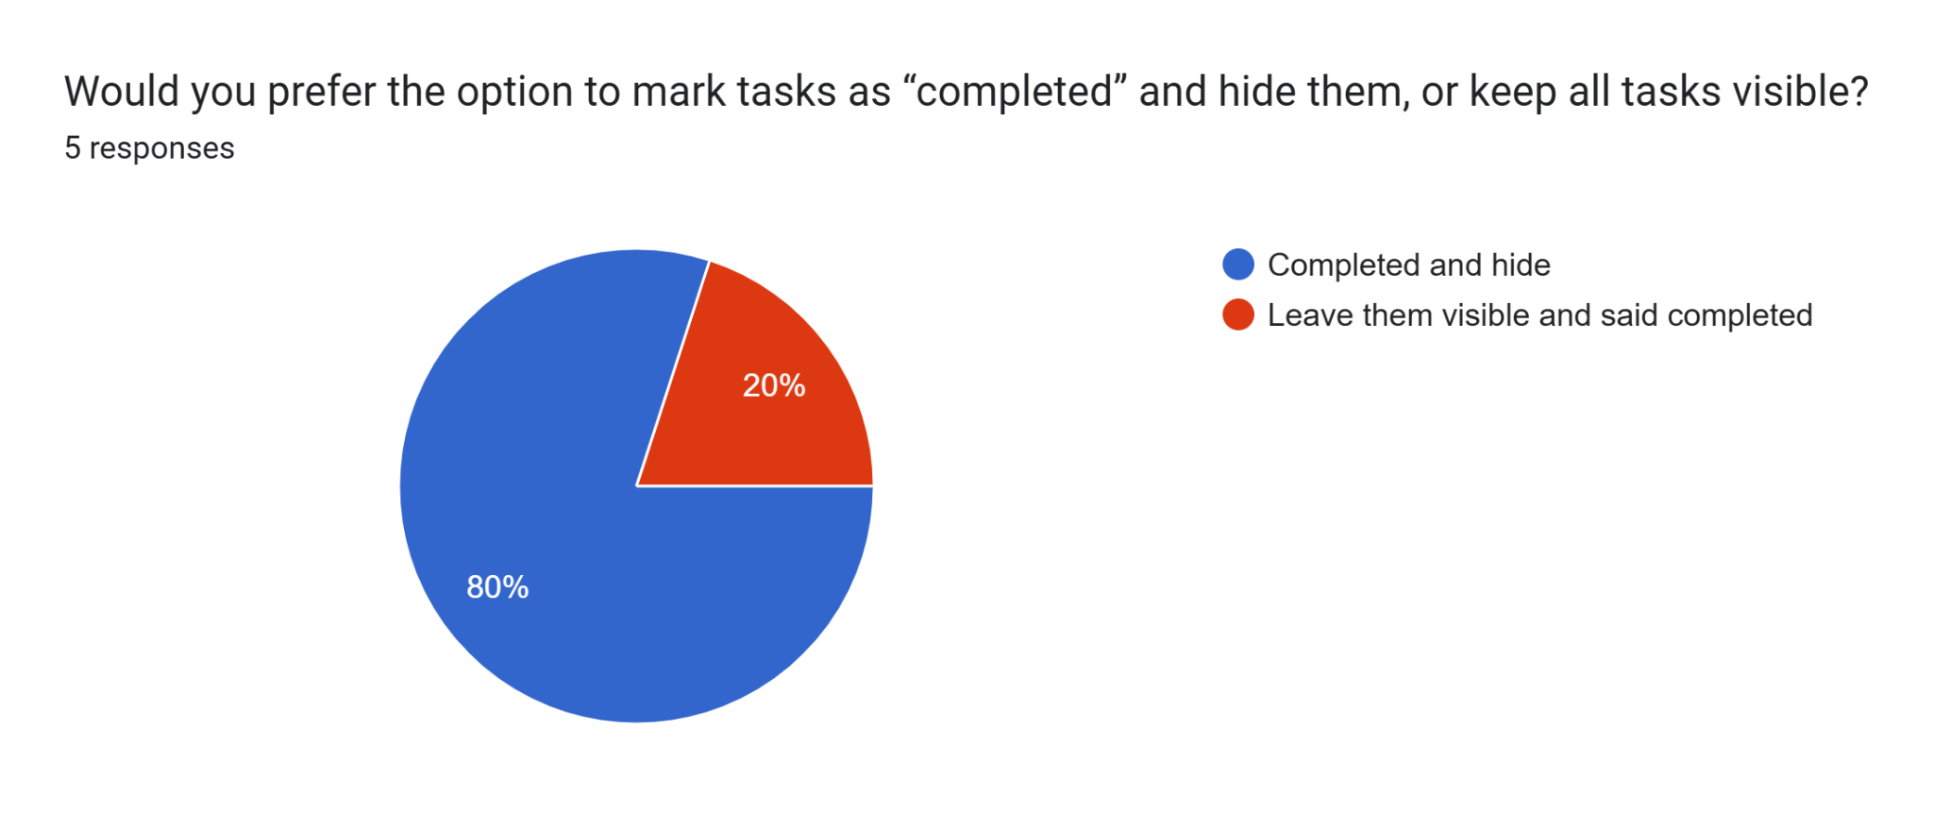
The students are again the direct users, with the indirect stakeholders being teachers and parents who want easy confirmation of work done. The 80% that want completed tasks hidden express a wish for a cleaner, less distracting interface in which to focus on remaining work, while 20% still want to be able to see it to track it. This calls for an adjustable feature to provide users the ability to hide or leave tasks visible when marking them complete.

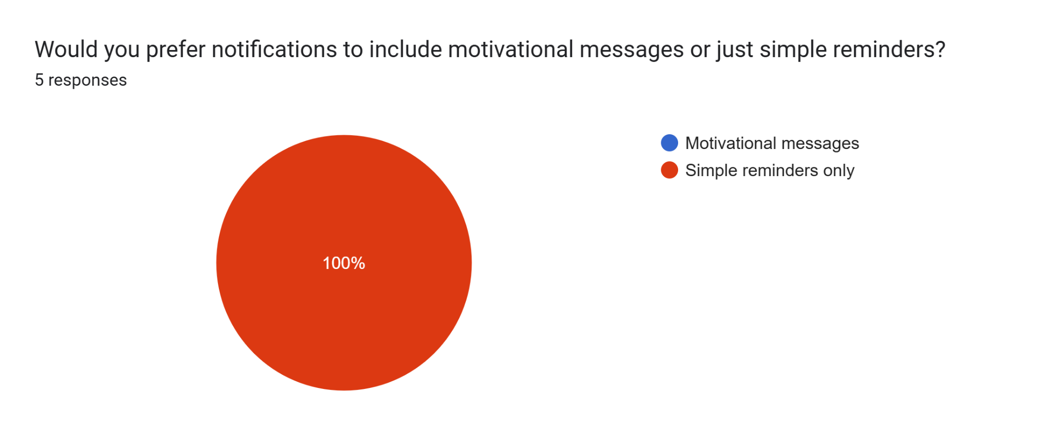
The immediate users are the students here, seeking useful but unobtrusive help with deadlines. Parents and educators may worry about distraction or annoyance at too much messaging. Because 100% of the respondents wanted simple reminders, it's clear the system should avoid extraneous motivational text and instead provide simple,’ to the point’ messages that respect students' requests for simplicity in communication.

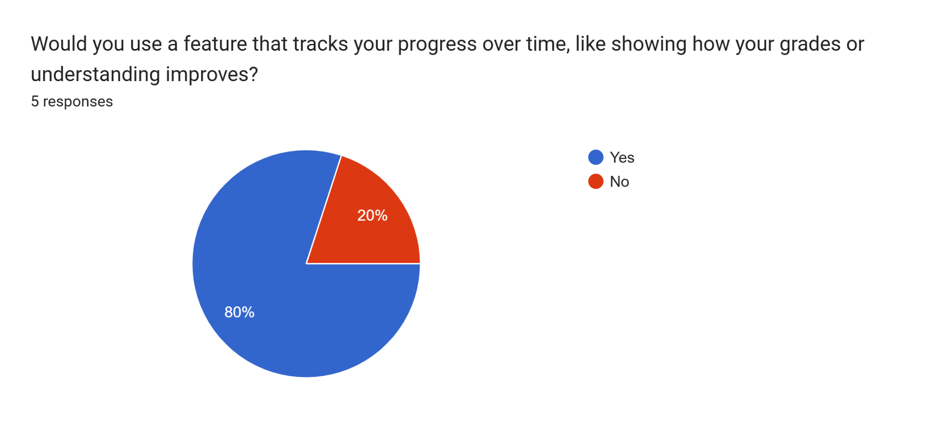
Stakeholders range from students who wish to track academic development, teachers who can foster self evaluation, and parents who monitor progress in the home. With 80% in favor of this feature, there is a high demand for a progress tracking component that allows students to consider enhancements and establish objectives. Yet, the 20% who have no interest indicate that it must be optional so as not to alienate users who do not wish to view this information.
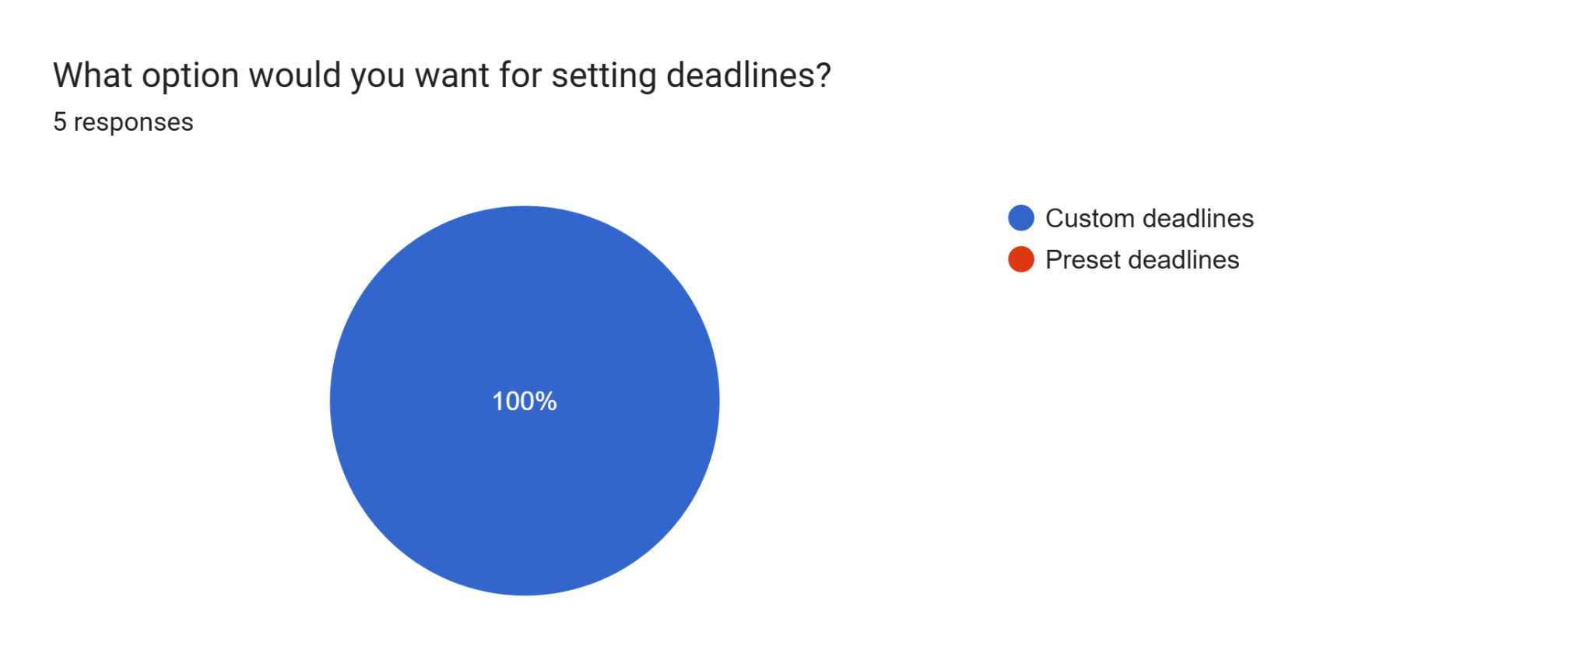
The end users are the students, who need flexibility to fit their own schedules, and the instructors want the students to take responsibility for planning. The overall 100% wanting individualised deadlines highlights that rigid systems will not work; the system must allow users to set and adjust deadlines to meet individual needs and workloads that change over time, reinforcing real world time management skills.

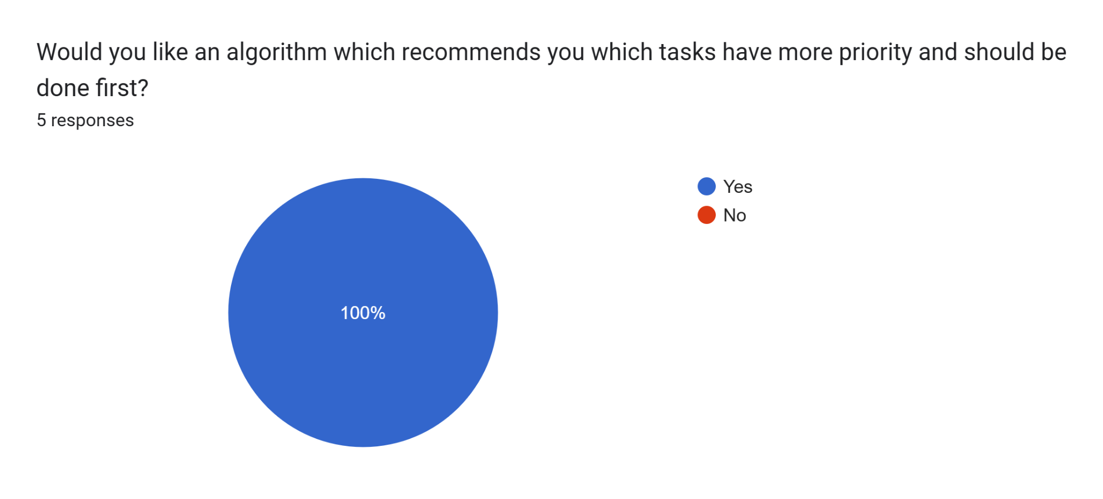
Students are directly assisted by being helped with prioritisation of competing demands, and teachers want students to complete the most important or urgent work first. The 100% positive feedback is that an intelligent prioritisation algorithm is needed, meaning the system should help users determine where to focus effort, reducing the feeling of being overwhelmed and improving academic performance.

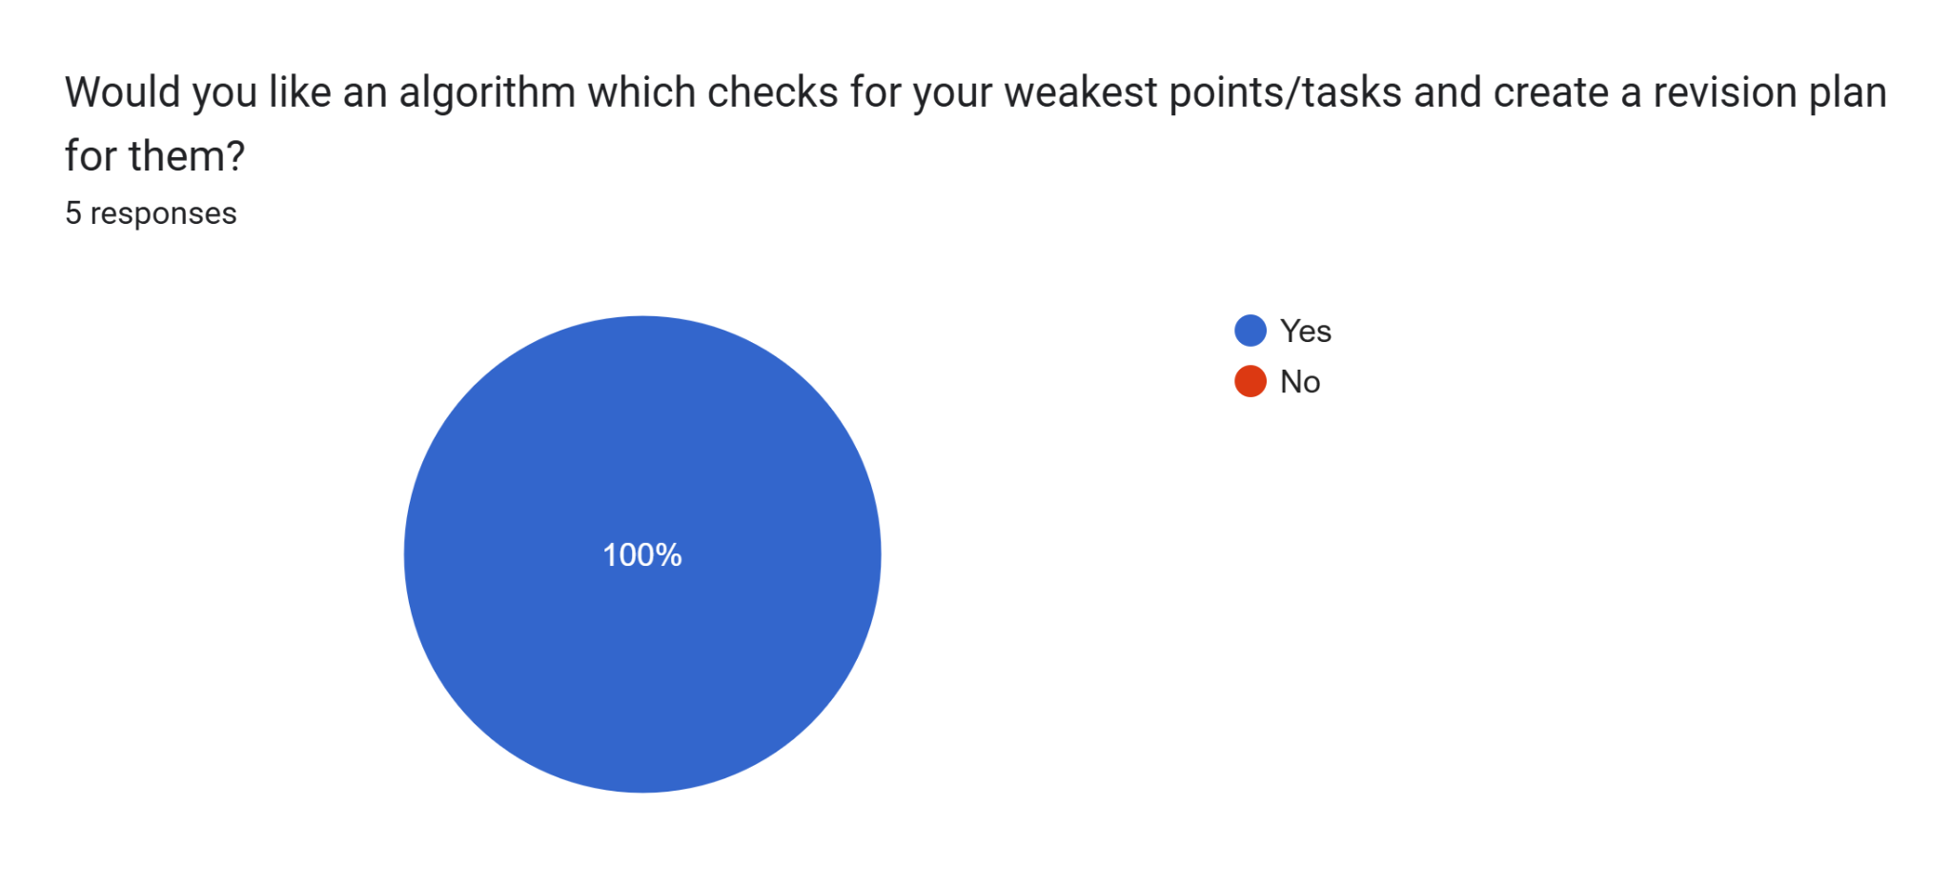
The direct beneficiaries of targeted revision plans are the students, enabling them to consolidate weak areas, with the teachers reaping the benefits of better prepared students and parents wanting to see improved performance. There is a unanimous 100% call for personalisation of learning in the solution, which means that the system needs to have diagnostic software and automatic planning to facilitate effective revision that is tailored to each student's needs.
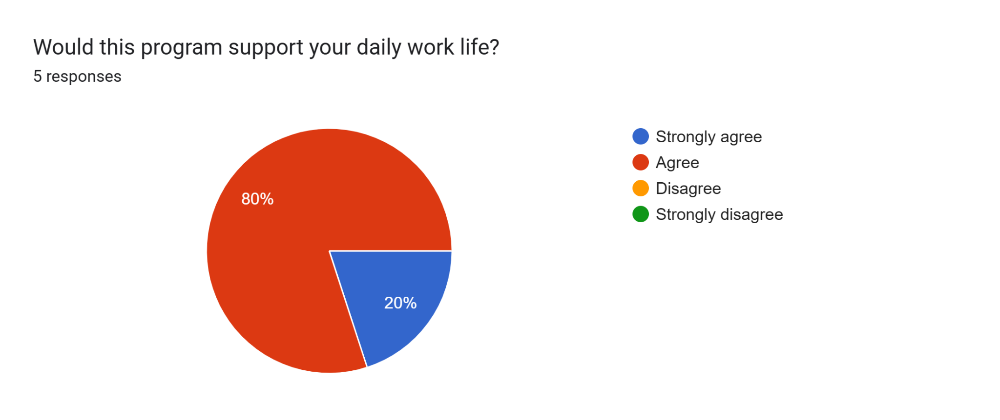
Students are the immediate stakeholders whose daily task load would be directly improved by such a program, with teachers benefiting from more organised and prepared students, and parents experiencing less homework tension. The result, with 80% in agreement and 20% strongly agreeing, demonstrates near unanimous belief in the positive impact of the program, confirming the value of designing an easy to use, everyday solution that slots itself readily into students' daily lives.

Research on Existing Solutions

Task creation with deadlines

All of the three systems; Google Classroom, Microsoft Teams, and Moodle; each provide basic task creation and deadline support. My system will go beyond the basic listing of tasks as just that by giving a user-friendly interface particularly designed for the 12–18 age bracket so that students can easily view closer deadlines and manage their load conveniently.

Push Notifications for Deadlines
Unlike Google Classroom, Microsoft Teams, and Moodle, which rely on email reminders or limited in-app reminders, my system will feature fully customisable, persistent push reminders. Students will receive real-time reminders that adjust to their schedule so they will never miss a deadline.
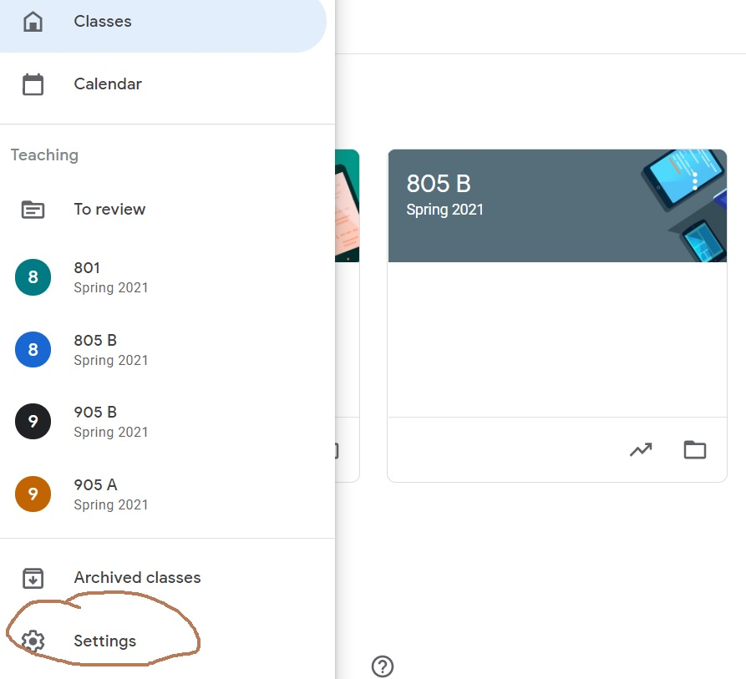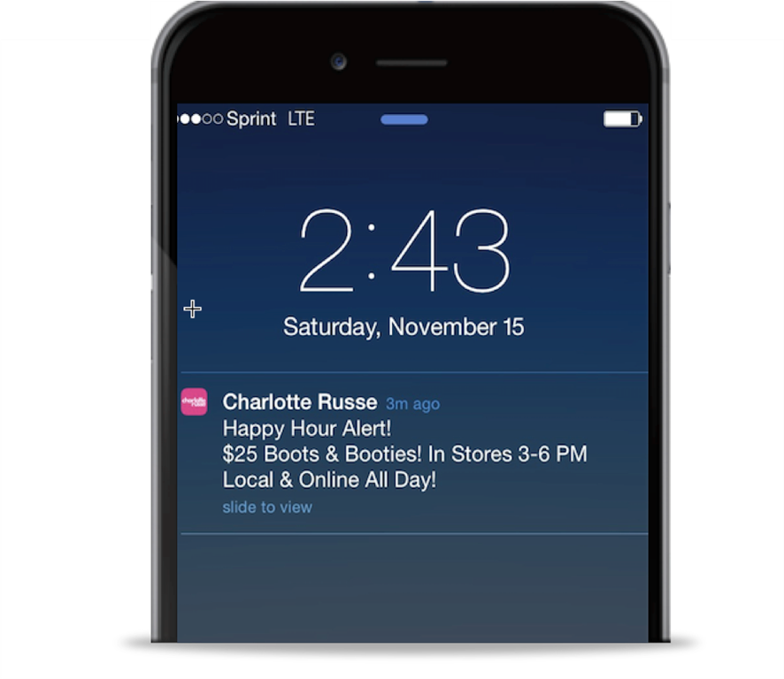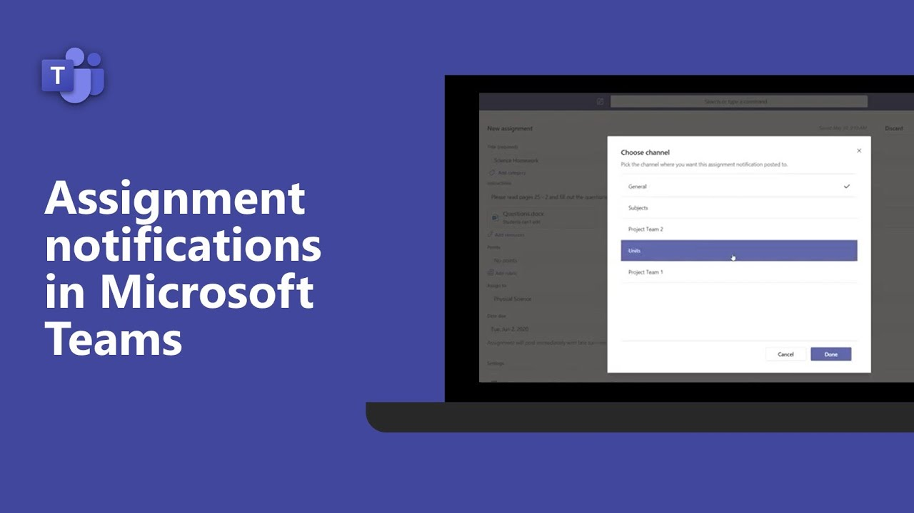

Personalised Revision Recommendations
While the other platforms offer no adaptive revision assistance, my system will analyse students' weakness and performance to generate personalised revision plans. This will be a smart process that will help students identify the most important things they need to work on to improve the most, hence making their study time immensely more effective.

Priority-based Task Scheduling (using Algorithms)
Google Classroom, Microsoft Teams, and Moodle lack advanced scheduling features. My system will feature algorithmic, priority-based task scheduling that automatically prioritises tasks by urgency and importance. This will reduce decision fatigue and teach students how to properly manage their time.

Use of Stacks/Queues for Task Management
While the rest of the systems display tasks as a simple list without smart ordering, my system will use stack and queue data structures to manage tasks in the most effective order. This allows students to tackle assignments in the optimal learning and efficiency order.

Revision Session Planning
Unlike others, my system will assist students in making informed revision sessions smartly. It will lead them through learning material in a rational, efficient order, minimising pre-examination stress and enhanced retention.

Integrated Communication Tools
While Google Classroom, Microsoft Teams, and Moodle all offer integrated communication tools such as chats, comments, and forums, my system will focus on streamlined study-first communication. I’ll design lightweight, purposeful communication features that keep students on-task without the distraction or complexity of corporate-style messaging systems.

Gradebook / Assignment Submission
Google Classroom, Teams, and Moodle all support assignment submission and grading workflows. My system will take a distinct, student-focused approach: instead of duplicating teacher grading, it will track student progress, self-assessment, and completion status, allowing students to control their learning journey.

File Submission / Resource Upload
While the others rely on antiquated file submissions, my system will enable easy attachment of resources for personal use, group study, or teacher comment, all in an easy, student-friendly format avoiding unnecessary complication.
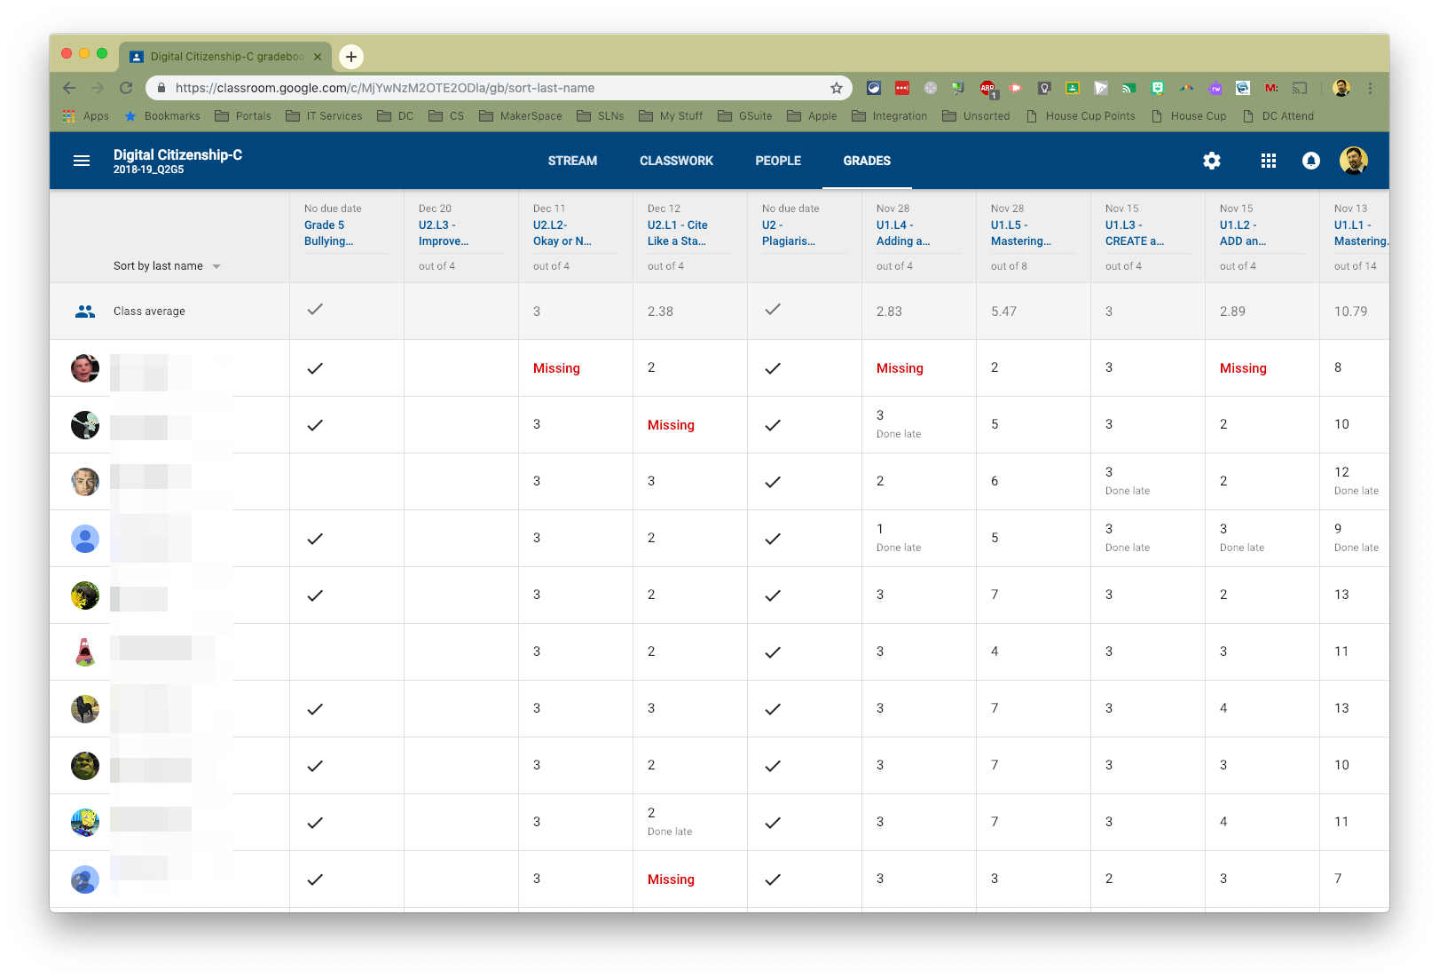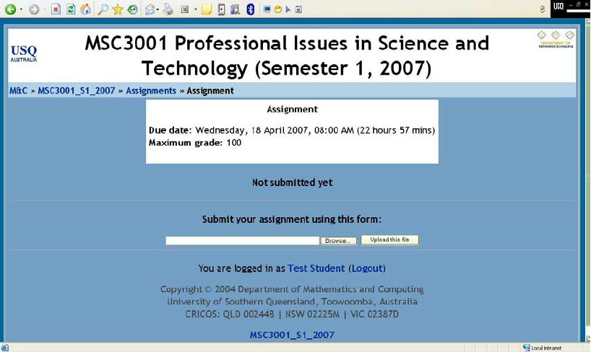

Calendar Integration
All of Google Classroom, Microsoft Teams, and Moodle come with integrated calendars. My system will not only include integration with widely used calendar software but dynamic scheduling that adapts as per the changing workloads, after-school activities, and individual study objectives of students.
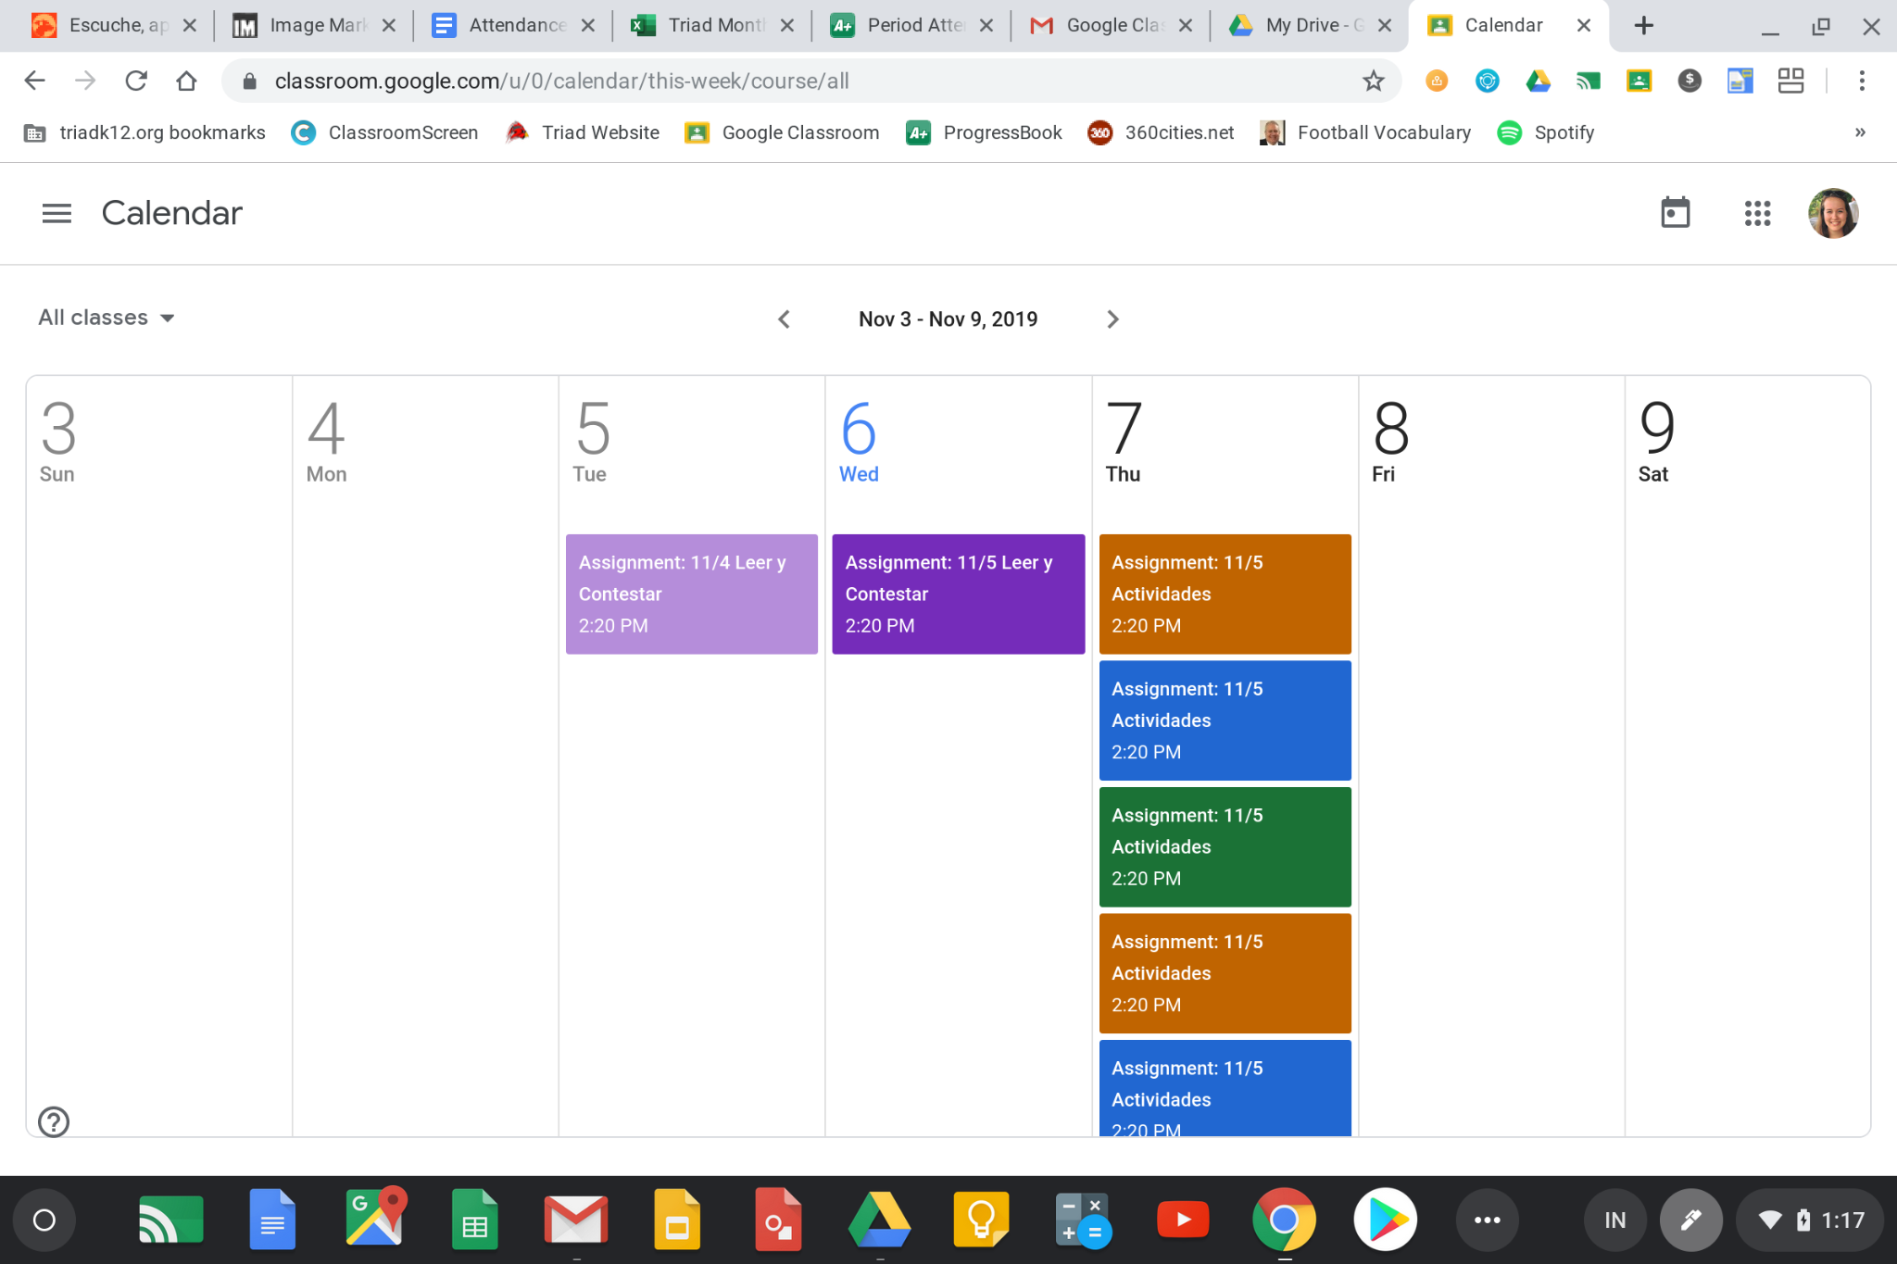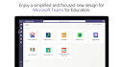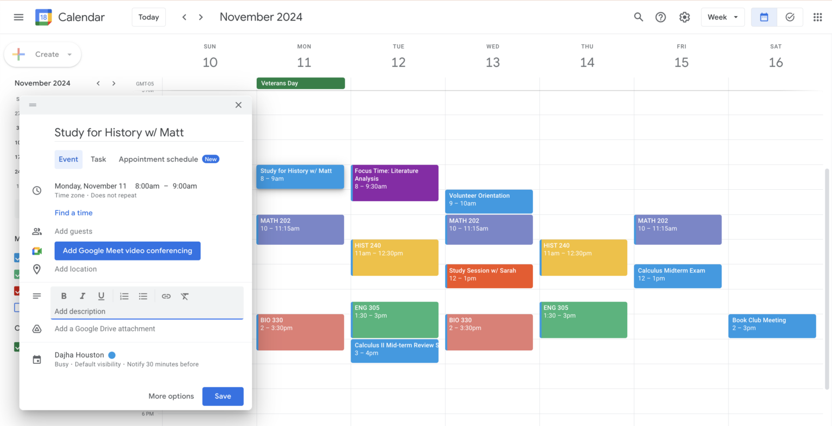

Mobile Accessibility
All major platforms are mobile-friendly, but my platform will be designed mainly for PCs’ first ,as it will encourage students to bring in laptops to school or college, as phones are typically a distraction for them. Also, this allows them to access their work anywhere connected to the internet.

User Target Group
Unlike generic platforms trying to serve all students at once, my system will be specially built for 12-18 year olds. Every detail, from interface design to learning recommendations, will be tailored to meet their developmental needs, learning behaviors, and academic needs.

Features I will be taking forward

- Clear task creation with deadlines and subjects as it directly supports student organisation
- Simple, uncluttered user interfaces to reduce cognitive load for students.
- Persistent data storage so tasks remain available between sessions.

Features I will not be taking forward

- Social or collaborative task sharing will not be included as it does not align with the individual focus of the problem and would increase complexity.
- Gamification features such as points or rewards as they distract from productivity rather than improving task completion

The core features of my to-do list application are intentionally designed to provide a focused and effective solution for student productivity. Essential elements like task creation with deadlines form the foundation, while push notifications address a major gap in current platforms such as Google Classroom and Moodle by ensuring students are alerted in real-time. A standout feature is the inclusion of personalised revision recommendations, which not only add educational value but are also a feature which the other 3 do not contain. I've implemented priority-based task scheduling using algorithms and stacks and queues, both which highlight computational thinking and demonstrate technical depth. Revision session planning further enhances the academic utility of the app, transforming it from a simple tracker into a learning companion. A simple and accessible GUI ensures users can navigate and manage their workload effortlessly. While additional features like calendar integration and mobile accessibility are valuable, they will be kept minimal or considered for future versions to avoid overcomplicating the project. Similarly, the reminder system will focus on streamlined push-styled alerts rather than complex background services. Features such as file submission, chat functions, or a grading system have been deliberately excluded, as they are more suited to full classroom management tools like Google Classroom, Microsoft Teams or Moodle. My app instead focuses on what students ages 12-18 need: clarity, prioritisation, and personalised academic support.

Essential Features
Pop-up notifications is a feature that will definitely be included in my system. This feature is essential due to its huge role in the system which is to remind users of their deadline completions. Notifications will appear clearly on-screen when a deadline is approaching, helping ensure students don’t overlook important tasks. The notifications will be designed to be noticeable but not disruptive, using simple language appropriate for students aged 12-18. This feature will be implemented using Python libraries capable of generating pop-up windows (for example, within the Pygame framework or using additional notification libraries if needed). By delivering reminders directly to the user’s screen, the system will improve time management and reduce the risk of missed deadlines.

Breaking up specification- This feature involves dividing the overall system into smaller, manageable components such as task creation, deadline input, priority calculation, revision planning, and notification delivery. By breaking up the specification in this way, development will be more organised and testing each part will be simpler, ensuring each feature works effectively before integration into the whole system. It will also make it easier to identify and fix bugs in isolated sections of the code without affecting the entire program. Additionally, this modular approach will allow for easier future updates, as new features or improvements can be added to specific components without needing to rewrite the whole system.

Data from a database is an essential feature as it will store user tasks, deadlines, and revision plans in a structured data format using an SQL database. This ensures that user data is saved between sessions so students can reliably access and update their tasks and revision plans even after closing the app. Using an SQL database provides more robust data handling than simple file storage, allowing efficient querying, updating, and organising of tasks. By keeping the data locally stored, the system will offer a simple and effective way for students to manage their workload without needing to re-enter tasks each time they use the application. It will be designed to be easy to implement and maintain within the scope of the project.

User login system is an essential feature that will be included in my system. This feature will allow users to create an account and log in using a username and password, ensuring that each user’s tasks and deadlines are kept separate and secure. A login system is important because it allows multiple users to use the application on the same device without accessing each other’s data. User account details will be stored in the database so that login information and associated tasks are saved between sessions. This feature will be tested by creating multiple accounts and checking that tasks are only visible when logged into the correct account. By including a login system, the application will feel more realistic, organised, and suitable for students aged 12-18 who may share devices at home or school.

Limitations
Platform focus- The application will be made primarily for laptop and PC environments, using the Pygame library, which is not natively supported by phones. This choice of platform limits usability for those students who would like to plan their work on phones or tablets, which are used more often during the course of a school day or on trips. Since phones represent a distraction, the decision to aim for desktop environments supports unbroken study. However, it also implies that users won't be able to see or edit their task list on the go unless they carry their laptop with them or use the software on a desktop computer.

User input dependence- The system's creation of accurate task priorities personalised revision timetables depends on the users entering accurate and honest information. If students fail to log some tasks, allocate incorrect deadlines, or are less than truthful about which subjects they are struggling with, the software may recommend unsuitable tasks or ineffective revision sessions. This is a human factor drawback, regardless of how excellent the system is, it can only operate effectively if the inputted information is relevant and up to date. Therefore, part of the success of the app depends on how frequently and how responsibly students use it

No automated integration with school systems- Homework and due dates have to be entered manually by students because integration with school databases, web portals, or learning management systems like Google Classroom or Moodle is not on the horizon. This manual entry approach places the burden on students to keep their task list current, which can lead to lost or outdated data if they fail to input new assignments. This approach, while it keeps the system simpler to develop and does not conflict with data privacy issues, lowers convenience and may reduce student adoption of the system, particularly for students who are used to having tasks auto-populate from school systems.

Personalised generation of revision for weak tasks- While the app will generate personalized revision plans based on user feedback of weaker topics and nearing deadlines, it cannot precisely tailor recommendations to each student's learning style or pace of learning. The system will use basic scheduling logic rather than adaptive AI, so recommendations won't account for differences like learning methods of preference (e.g. flashcards versus practice questions), neurodiversity, or special educational needs. It also can't replace a teacher's potential to clarify misconceptions or make spontaneous plans.

Hardware and Software Requirements
The softwares I will be using to develop my program are Visual Studio code and Pygame. Visual Studio Code is the primary IDE used for development, while Pygame is the framework used to build the graphical user interface.

Alternative IDEs such as Pycharm were considered. Pycharm is more resource-intensive and has higher system requirements, which makes it less suitable for development on standard college computers. As a result, Visual Studio Code was chosen because it is lightweight, runs efficiently on lower-spec hardware and still provides essential features such as debugging, extensions and syntax highlighting.

Component | Recommended Specification
CPU | Intel Core i5 or AMD Ryzen 5 or higher
RAM | Minimum 8GB(recommended: 16GB)
Storage | At least 2.5GB for IDE + project files
Operating System | Windows 10/11, macOS, or Linux
Display | 1920x1080 resolution for comfortable layout

These requirements further justified the decision to use Visual Studio Code instead of other IDEs such as Pycharm as CS Code performs reliably on lower-spec systems commonly found in schools and colleges.

The primary hardware used for this project will be a standard laptop or desktop PC with a keyboard and mouse, which are essential for writing, testing, and debugging the code. Speakers, while optional, could be helpful if I decide later on to implement sound-based notifications. Reliable internet access is also necessary throughout the development process for downloading software and libraries, and updating tools.

A standard laptop or desktop PC was chosen to ensure the system can be developed and tested in a typical school or home environment, making the project realistic and accessible to its target users.

The software stack for this project centers around Python which will be used to build the application logic and user interface. To implement the reminder system, libraries such as ‘plyer’ or ‘ToastNotifier’ will be used to generate push-style alerts notifying users of upcoming deadlines. An IDE such as Visual Studio Code will support development with features like debugging tools, and project organisation. On the hardware side, the keyboard and mouse will be used to navigate the interface and test user interactions with the app. The internet will play a critical role in referencing external documentation, accessing online coding communities for support, and ensuring all necessary dependencies and libraries are kept up to date.

Other programming languages such as Java and C# were considered. However, Python was chosen because it has a simpler syntax, a wide range of libraries and is commonly taught at GCSE and A level, making it more suitable for rapid development and future maintenance.

Suitability for Solving by Computational Methods

Abstraction | My solution will simplify the complex real-world problem of managing student tasks, deadlines and study plans into a clear digital system. It abstracts multiple responsibilities, task tracking, priority setting, revision guidance, and reminders into manageable components, making the problem easier to handle computationally
Decomposition | My overall system will be broken down into smaller, manageable parts such as:  Task creation and deadline input  Algorithms for priority determining  Revision recommendation  Notification system for reminders  GUI for task display in the format of calendar.
Selection | My program uses conditional statements to decide which tasks to prioritise based on criteria such as deadline, task priority, and user weaknesses. For example if a task is urgent and related to a weak subject, it will be recommended first; otherwise, lower priority tasks are delayed.
Iteration | Several features in my project will involve repetition, such as looping through tasks to check for approaching deadlines, repeatedly updating task priorities, and cycling through revision recommendations until all relevant topics are covered.
Modelling | The system models student workloads and study habits by representing tasks, deadlines, revision sessions, and notification schedules as data structures, closely mimicking real-world academic planning.
Visualisation | I will provide a GUI that visually presents tasks, deadlines, and revision sessions clearly to users, making it easier for them to understand and manage their workload
Divide & Conquer | My priority algorithm can split tasks into groups (urgent vs non-urgent, weak vs strong subjects) to reduce complexity. This helps the system recommend which tasks to focus on first, making the problem more manageable.

Success Criteria

- Need To have a good working GUI- I will physically watch someone enter tasks and set deadlines to ensure it works properly. I will also be issuing surveys to other users to make sure that they are able to input tasks and deadlines ensuring it is a good working GUI . A success in this feature would be distinguished through the results of the survey being at least 80% of users or above confirming they were able to input tasks and deadlines without assistance.
1.1. Need to be in a calendar format- Alpha testing will take place to ensure this feature works, this feature will help the user to clearly visualise all tasks in chronological order. I will observe users interacting with the calendar view to check they can easily see which tasks are due on which dates. I will also issue surveys to confirm whether users find the calendar layout clear, understandable, and helpful for planning. Success in this feature will be defined as over 80% of users agreeing that the calendar view clearly shows tasks in chronological order and helps them manage deadlines
1.2 Should allow users to input deadlines which are customisable- This enhances the quality of the system as they can customise their deadlines in case of a granted extension. I will test this by having users input, edit, and update deadlines for their tasks to simulate real-life situations such as deadline extensions or changes in schedule. I will observe whether the system properly updates the stored deadlines and reflects the new dates in the interface. Success will be measured by user surveys and observation, aiming for at least 80% of users confirming they were able to customise and update deadlines successfully.
1.3 Should store tasks using a database- The system should store all tasks in a database so that tasks are not lost when the program is closed. I will test this by adding tasks, closing the program, and reopening it to check if the tasks are still there. I will also test this using different user accounts to ensure tasks are saved for the correct user. A success in this feature would be defined as tasks always being saved and reloaded correctly in repeated tests and at least 80% of users confirming their tasks were still available after reopening the program.
1.4 Should allow users to create accounts and log in- The system should store all tasks in a database so that tasks are not lost when the program is closed. I will test this by adding tasks, closing the program, and reopening it to check if the tasks are still there. I will also test this using different user accounts to ensure tasks are saved for the correct user. A success in this feature would be defined as users always being able to log in successfully and access only their own tasks, with at least 80% confirming this worked correctly.
2. Should determine task priority and recommend which tasks to do in order- Alpha testing will take place and input multiple tasks with different deadlines, based on the deadline date, tasks will be put in order of completion. I will observe users entering a range of tasks with varying urgency and difficulty, and check that the system correctly reorders them based on priority rules. I will also ask users if they feel the recommended order makes sense and helps them focus on important work first. A success in this feature would be defined as at least 80% of users agreeing in a survey that the recommended task order was logical and helpful
2.1 Should create revision plans for weak tasks- I will ask users to enter tasks they consider weak, and check that the application generates structured revision plans with suggested dates and times. I will run a practical test where users input weak areas and then review the generated plans for clarity and usefulness. A success in this feature would be that at least 80% of users rate the generated plans as helpful or very helpful.
2.2 Should remind users about upcoming due tasks multiple times- I will have users input tasks with close deadlines and observe whether they receive repeated reminders before the deadline. I will test by timing how often reminders are issued and ask users to confirm if they felt the reminders were sufficient without being annoying. Success would be shown by at least 80% of users stating in surveys that the reminder frequency was helpful.
2.3 Should use pop-up notifications to remind the user about their deadlines- I will watch users interact with the system to ensure pop-up notifications appear clearly and instantly and only last around 5 seconds and are then removed from the screen when a deadline approaches. I will conduct direct observation sessions and user interviews to verify that notifications are noticeable, timely, and easy to understand. Success would mean over 80% of users agree that the pop-up notifications helped them remember deadlines
2.4 Should allow users to view both tasks and revision sessions on the same day- The system should store all tasks in a database so that tasks are not lost when the program is closed. I will test this by adding tasks, closing the program, and reopening it to check if the tasks are still there. I will also test this using different user accounts to ensure tasks are saved for the correct user. A success in this feature would be defined as both tasks and revision plans always appearing correctly on the same day, with at least 80% of users confirming this feature worked as expected.
2.5 Should automatically update revision plans when tasks change- If a task is edited or deleted, the system should automatically update the related revision sessions. I will test this by editing and deleting tasks and checking that the revision sessions update correctly. A success in this feature would be defined as revision sessions always matching the current task details during testing and at least 80% of users agreeing that revision plans stayed accurate.
2.6 Should automatically order tasks by priority- The system should automatically decide which tasks are more important based on how soon they are due and how difficult they are. I will test this by entering tasks with different deadlines and difficulty levels and checking the order they appear in. A success in this feature would be tasks consistently appearing in a logical order and atleast 80% of users agreeing the order was helpful.
2.7 Should allow users to log out safely at any time- The system should allow users to log out whenever they want without losing their data. I will test this by logging out from both the calendar view and list view to ensure it always returns to the main menu correctly. A success in this feature would be that logging out always works correctly during testing and at least 80% of students agreeing the system was easy to use and understand.
3. It should be suitable to students aged 12-18- I will recruit participants within this age group to use the application and provide feedback on ease of use, language, and design appropriateness. I will use targeted surveys and short interviews with these students to ensure the interface and instructions are age-appropriate. Success would be defined as at least 80% of students agreeing the system was easy to use and understand.
3.1 Should display clear error messages for incorrect input- The system should show clear error messages when users enter incorrect information. I will test this by entering incorrect data such as empty fields and invalid times. A success in this feature would be atleast 80% of users confirming they understood what went wrong based on the error messages.
4. It will be created on pygame- I will build the system using the pygame framework to deliver a graphical interface. I will verify this by reviewing the source code to ensure pygame is used throughout the GUI development. A success in this feature would be confirmed through successful code review showing Pygame is used for all interface elements.
4.1 Should use Pygame for all interface features- All parts of the system should be created using Pygame. I will verify this by reviewing the source code to confirm that Pygame is used for all interface elements. A success in this feature would be confirmed if the entire interface runs correctly using only Pygame components

Appendix 1: Stakeholder Interviews
https://docs.google.com/forms/d/1YQ63Bk2rQsMmhJLX2AbAjnz-_Te880V6EJIpxqjzhOM/edit

References

